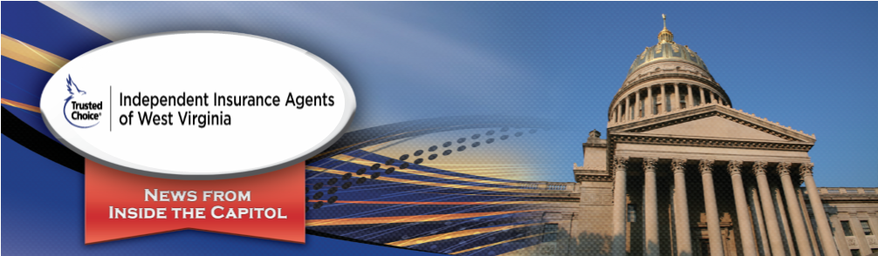
Special Edition June 10, 2020

West Virginia’s Primary Election 2020

Senate President Mitch Carmichael loses Primary Election; West Virginia’s Primary Election 2020

In a shocking defeat, current Senate President Mitch Carmichael appears to have lost his re-election bid to political newcomer Amy Nichole Grady by a 39% to 35% margin in the 4th Senatorial District. Delegate Jim Butler received 26% of the vote.

President Trump, US Senator Shelley Moore Capito, Governor Jim Justice and West Virginia’s three Congressional Representatives breezed to victory.

Governor Justice captured 63% of the vote to Woody Thrasher’s 18% and former Delegate Michael Folk’s 12%. On the Democrat side, Charleston trial lawyer Ben Salango won his party’s nomination over Stephen Smith by a 39% to 33% margin. State Senator Ron Stollings received 14% of the vote.

Delegate Isaac Sponaugle won a close contest for the Democratic nomination for Attorney General and will face incumbent Patrick Morrisey this Fall.

Tim Armstead and John Hutchinson won their re-election bid for the Supreme Court of Appeals and Beckley native and Former Legislator Bill Wooten is holding a slim 31% to 30% lead over Kanawha County Circuit Judge JoAnna Tabit.

Legislatively, Senator Sue Cline (Wyoming Co.) and Senator John Pitsenbarger (Nicholas Co.) lost their re-election bids, as did Delegates Eric Porterfield (Mercer Co.), Chuck Little (Jackson Co.), Scott Cadle (Mason Co.), Rick Atkinson (Roane Co.), Former House Majority Leader Daryl Cowles (Morgan Co.) and Larry Kump (Berkeley Co.).

Please note these results are preliminary and a complete analysis of the Primary Election will become official over the next week or so as all counties report, mail-in ballots are tabulated, and all canvassing and challenges are completed.

If you have any questions, please contact Daniel Hall at daniel@omegawv.com or you can call the office at 304.342.2440 and leave him a message. You may also contact Traci Nelson at traci@omegawv.com or at 304.342.2440.

2006 Kanawha Blvd. East
Charleston, WV 25311
Phone: 304.342.2440 – iiawv.org

