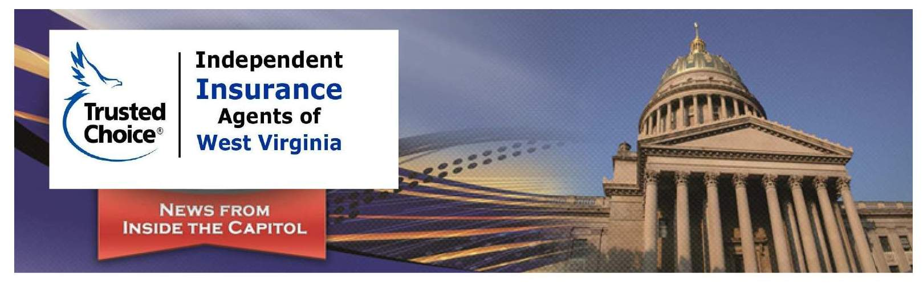
2019 West Virginia Legislative Session Wrap-up
The first regular session of the 84th Legislature is now in the books, as both the House and Senate adjourned at midnight Saturday March 9, 2019. A total of 1,823 bills were introduced, with 294 being sent to the Governor (per the House Clerk, this is the highest number since 2002).

Once again education was a hot topic at the Capitol. The Legislature sent SB 1 to the Governor, which provides tuition assistance for post-secondary education. Another attempt was made at education reforms (including Charter Schools and Education Savings Accounts “ESAs”), only for the bill to die on a procedural vote in the House. In response to the proposed reforms, the state’s two largest educator unions called for a work stoppage that lasted two days.

Several tax reductions were adopted this year including: Social Security, Steam Coal Severance, Marginal Oil and Gas Well Severance, Annuity Tax by Life Insurer, Limestone Severance and the Petroleum Evaporation Tax Refund. There were also significant changes regarding the sale of alcohol adopted this year, including the sale of liquor on Sundays.

Overall, we had a very successful Legislative Session by advancing bills that are favorable to our industry. But, just as important, maybe even more so, we were able to defeat a great number of bills that, if adopted, would have been major setbacks. A considerable amount of time is spent at the Capitol with legislators explaining the negative impacts of such legislation.

While we have a somewhat business-friendly Legislature, I anticipate a continued onslaught of bills next year that we must work to defeat.

Following is a list of bills that we worked on and/or supported that passed that will affect our industry:

- SB 30 - Eliminating tax on annuity considerations collected by life insurer. This bill completed legislation and is awaiting the Governor’s signature.
- SB 485 - Clarifying notification requirements for property insurance purposes. The purpose of this bill is to define reduction in coverage and to clarify what a termination means in regard to property insurance. This bill completed legislation and is awaiting the Governor’s signature.
- HB 2476 - Relating to the valuation of a motor vehicle involved in an insurance claim. The purpose of this bill is with respect to a cash settlement for a motor vehicle loss insurance claim, substitute the requirement that the settlement value include an amount equal to an excise tax imposed for the registration of vehicles with a requirement that the settlement value include an amount equal to the consumers sales tax levied when a vehicle is purchased. The amendment brings §33-6-33 into conformity with the taxation of motor vehicles, following the repeal of the five percent excise tax and replacement with the consumer sales tax. This bill completed legislation and is awaiting the Governor’s signature.
- HB 2480 - Relating to the regulation of an internationally active insurance group. The purpose of this bill is to provide authority to a designated state insurance commissioner to act as a group-wide supervisor for an internationally active insurance group. For a holding company group to be considered an internationally active insurance group, it must meet various criteria, including premiums written in at least three countries, at least 10% of premiums written outside the United States, and total assets greater than $50 billion or total premiums greater than $10 billion. The legislation is needed for the State of West Virginia to remain accredited with the National Association of Insurance Commissioners. This bill completed legislation and is awaiting the Governor’s signature.
- HB 2617 - Relating to the form for making office of optional uninsured and underinsured coverage by insurers. The purpose of this bill is to require the Insurance Commissioner to provide for the use of electronic means of delivery and electronic signing of the form for making an offer of optional uninsured and underinsured motorist coverage by insurers. It also requires an insurer, when offering to place an insured with an affiliate of the insurer, to make available a new uninsured and underinsured motorist coverage offer form. This bill completed legislation and is awaiting the Governor’s signature.

Following are bills that did not pass that we actively worked against that would have had a negative impact on our industry:
- SB 508 - Creating private state exposure property and casualty insurance company. The purpose of this bill is to create a private state exposure property and casualty insurance company to provide insurance coverage for the state's property and casualty exposures.
- HB 3147 - Requiring the Board of Insurance and Risk Management purchase life insurance products from state resident agents. The purpose of this bill is to require BRIM or its insurers to purchase life insurance products from licensed agents who are residents of West Virginia.

Business
Following are business-related bills that completed legislation.
- SB 4 - Relating to the Municipal Home Rule Program. This bill reauthorizes the Home Rule Program. This bill completed legislation and is awaiting the Governor’s signature.
- SB 360 - Relating to third-party litigation financing. The purpose of this bill is to establish Consumer Litigation Funding requirements, including definitions, financier requirements, prohibitions, mandatory contract language; third party agreements, violations, and contingency rights. We supported this legislation. This bill completed legislation and is awaiting the Governor’s signature.
- SB 377 - Relating to the minimum wage and maximum hour standards. The purpose of this bill is to exclude seasonal amusement park workers from the definition of “employee” for the purposes of maximum hours standards. We monitored this legislation because of the possible implications on all businesses. This bill completed legislation and is awaiting the Governor’s signature.

If you have questions regarding any of the legislation listed above, please contact Daniel Hall at daniel@omegawv.com.

